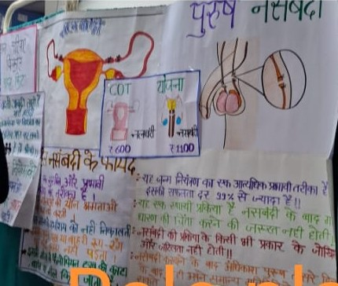
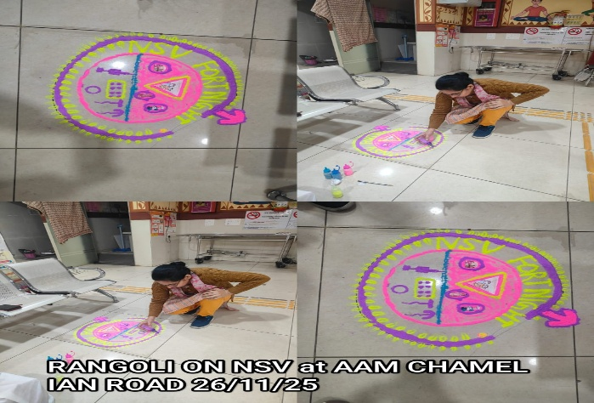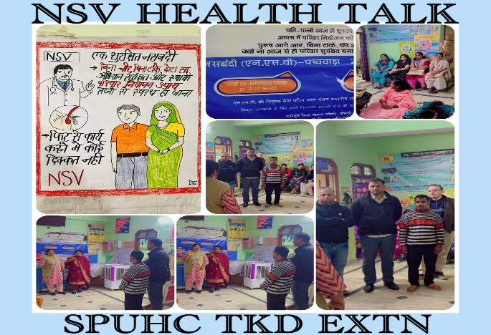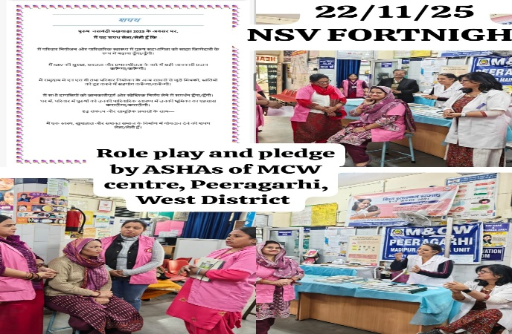Vasectomy Fortnight report-2025,Family Planning Section, DFW, GNCTD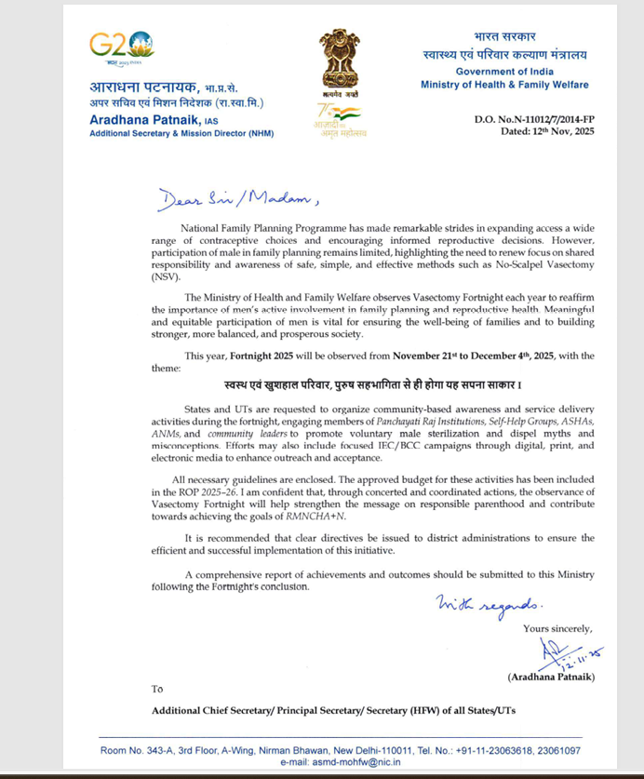"D.O. Letter from Additional Secretary & MD (NHMM), MoHFW, Regarding NSV Fortnight: Strengthening Family Planning Initiatives!"

Brief Summary
The Vasectomy Fortnight (VF) 2025 successfully promoted male participation in family planning through a series of sensitization, outreach, and counselling events. These efforts were driven by intersectoral collaboration among healthcare departments and enthusiastic participation by medical professionals and support staff. Key activities included curtain-raising events, motivational sessions, health talks, and innovative community engagement programs like Nukkad Natak performances.

Activities and Highlights

1. Pledge and Sensitization Events
- A pledge ceremony was conducted during the NSV Sensitization Meeting at Maharishi Valmiki Hospital, South-West district, marking the event's commitment to family planning objectives.
- Sensitization meetings were organized across multiple locations to educate healthcare staff and enhance their role in promoting No-Scalpel Vasectomy (NSV).

2. Curtain-Raising Events
- **Chai ki Tapri Initiative:** Family planning videos were displayed at the male window of SVBP Hospital to engage male clients effectively.
- **Motivational Activities:** ANMs and ASHA workers motivated male partners at Mrs. Girdhar Lal Maternity Hospital.

3. Community Outreach Programs
- **Nukkad Natak Performances:**
- **Health Talks:** Conducted by the Gynecology and Surgery Departments at hospitals across the Delhi.
- **Demand Generation:** Nukkad Natak performances at JPCand other health fcailities successfully raised awareness and generated interest in family planning services.

4. Counseling and Motivation
- **One-to-One Counseling:** Conducted to address individual concerns and provide tailored advice.
- **NSV Video Displays:** Videos showcasing the benefits of NSV were screened at various Hospitals to create demand for the procedure.
- ** Active client motivation in OPD settings highlighted the importance of male involvement in family planning.

Intersectoral Convergence
A collaborative NSV sensitization meeting was held at various health facilities. The meeting included:
- Representatives from surgery, homeopathy, AYUSH, Unani, dietetics, and HIV counseling departments.
- Discussions on strategies to enhance male participation in family planning.
Additionally, sensitization meetings targeted supportive staff, including security guards, nursing orderlies, housekeeping staff, and OPD personnel.

Achievements and Feedback
- High engagement in Nukkad Natak performances and health talks, with positive audience feedback.
- Increased awareness and acceptance of NSV among male clients through counseling and motivational activities.
- Strengthened collaboration between departments, enhancing the effectiveness of family planning initiatives.

Recommendations
1. Expand community engagement programs like Nukkad Natak to rural and underserved areas.
2. Increase the frequency and scope of one-to-one counseling sessions at healthcare facilities.
3. Leverage digital platforms to disseminate NSV-related information widely.
4. Strengthen interdepartmental coordination to maximize resource utilization.
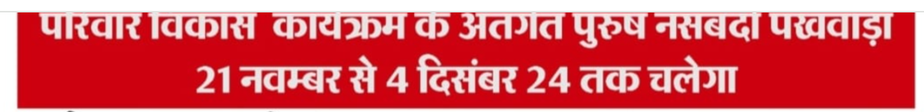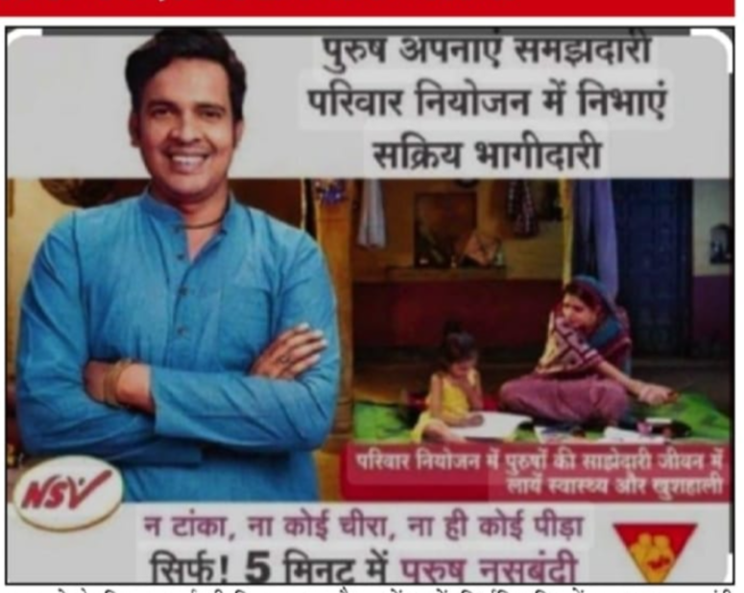

"Office Order Issued for the Movement of NSV Surgeons During!"
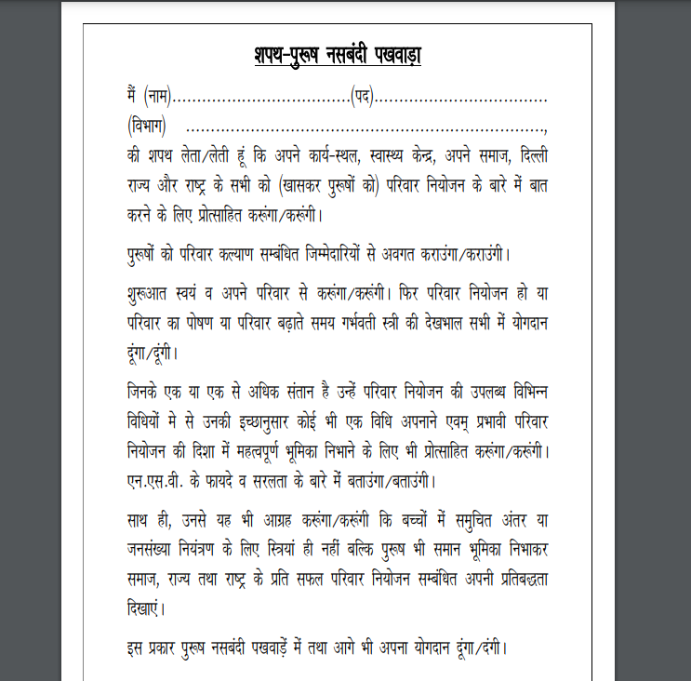
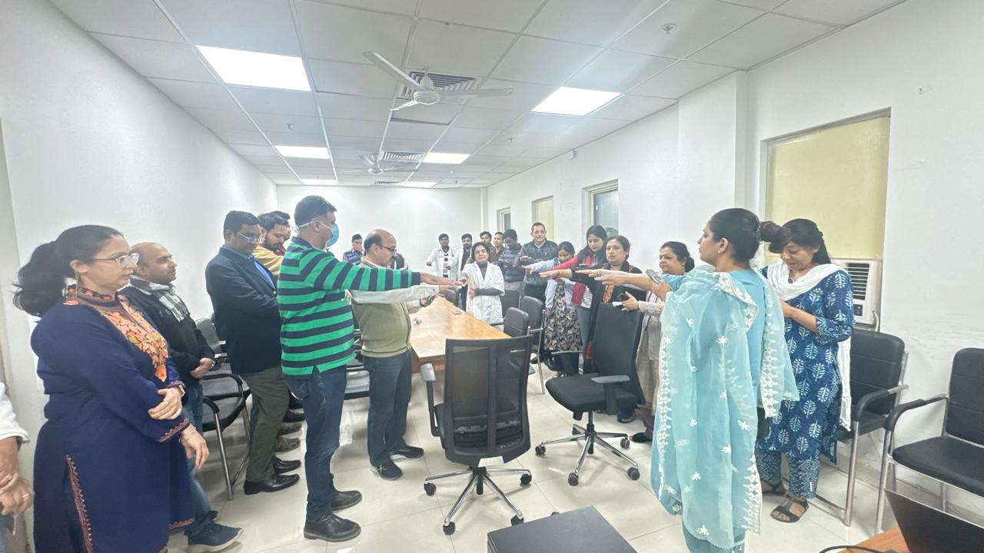
A meeting was held in the chamber of the Medical Director (MD) regarding promotion of Non-Scalpel Vasectomy (NSV) and enhancement of male participation in family planning services. The meeting was attended by all Deputy Medical Superintendents (DMSs) and Heads of Departments (HODs) of Burari Hospital.
All departments were sensitized and motivated to actively participate in the NSV campaign and to counsel and motivate eligible beneficiaries. A pledge for promoting NSV and strengthening male involvement in family planning was also administered to all participants in the Conference Hall.

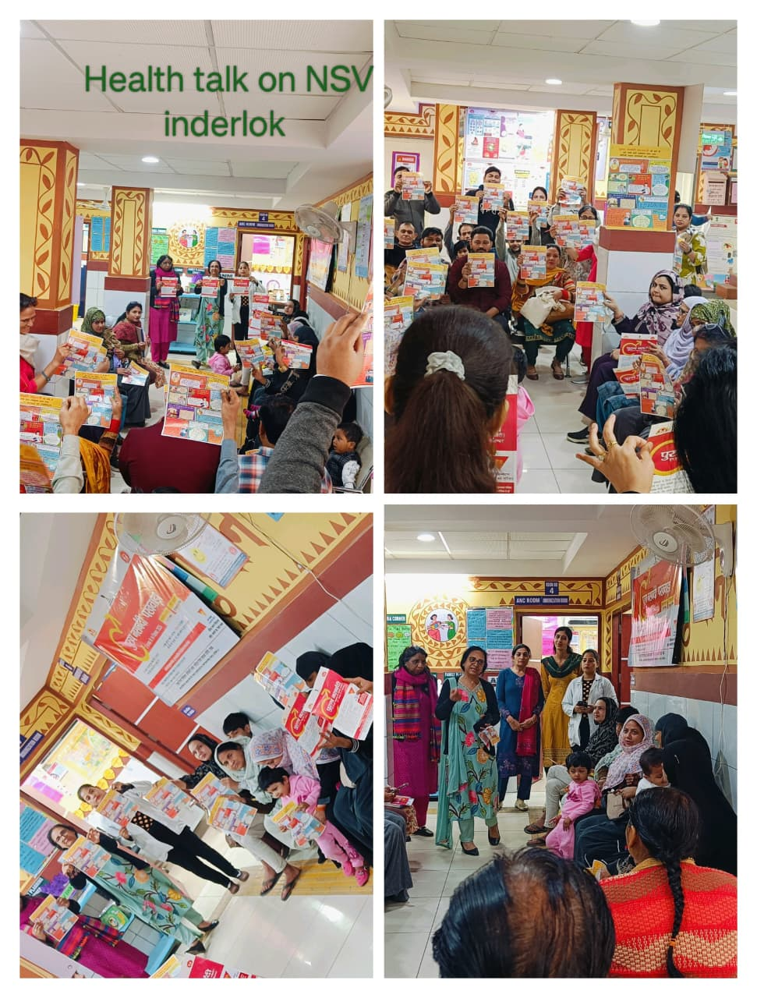
"Commitment to Family Planning: Pledge Taken During NSV Sensitization Meeting at Maharishi Valmiki Hospital, South-West District!"

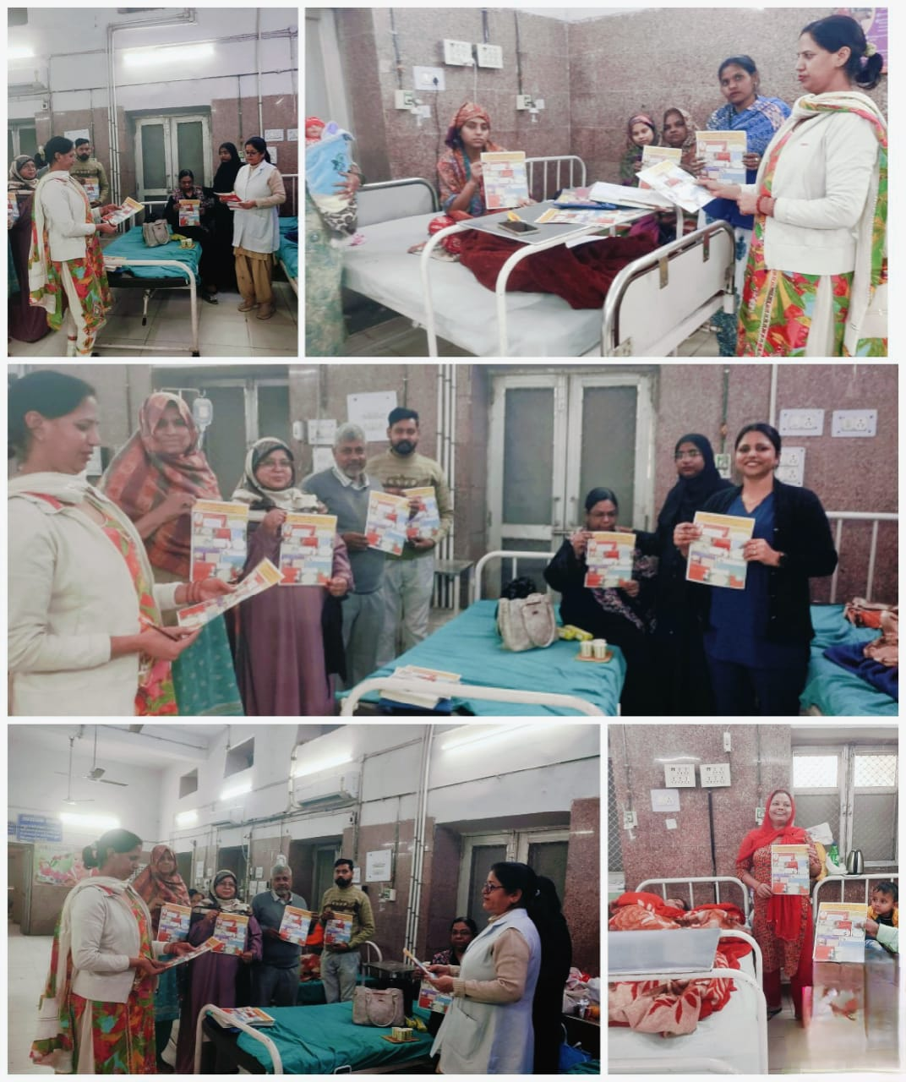
A health talk on Non-Scalpel Vasectomy (NSV) was conducted at Girdhari Lal Maternity Hospital to create awareness and promote male participation in family planning services. Eligible beneficiaries and attendees were sensitized about the benefits, safety, and effectiveness of NSV, and myths and misconceptions were addressed.
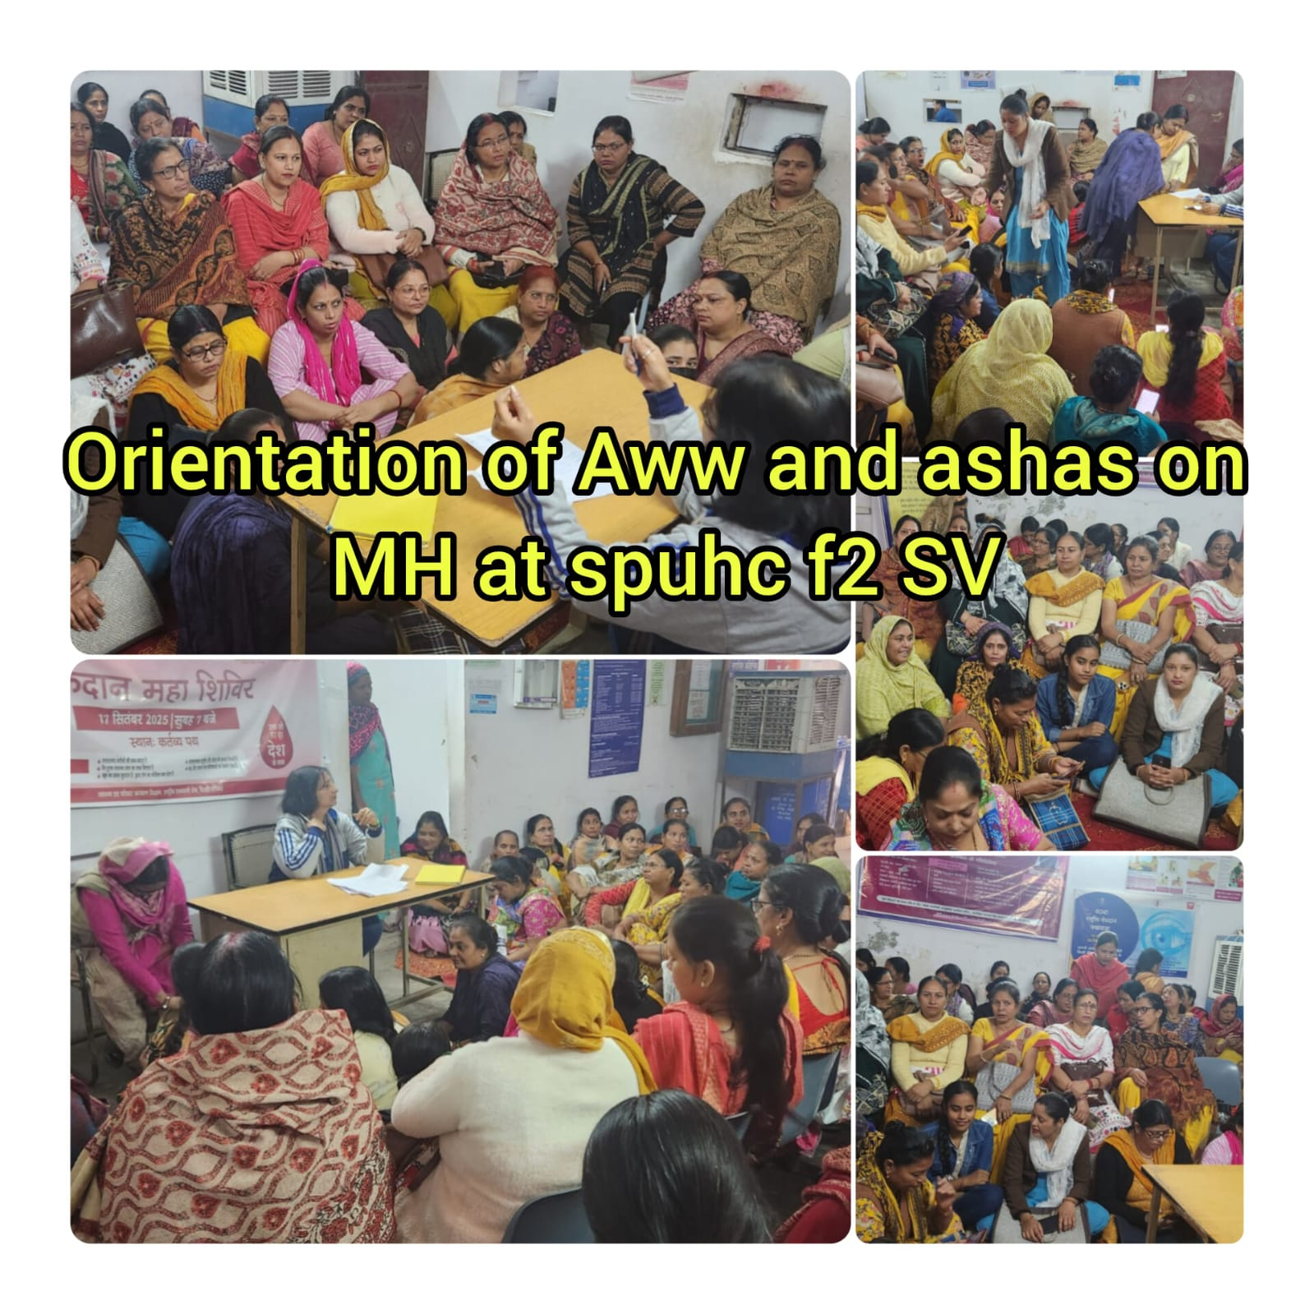
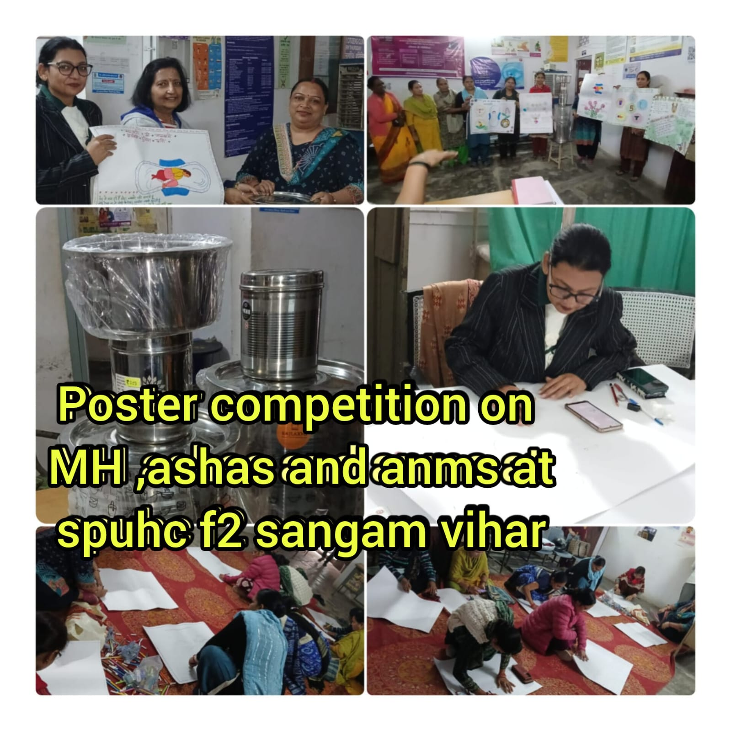
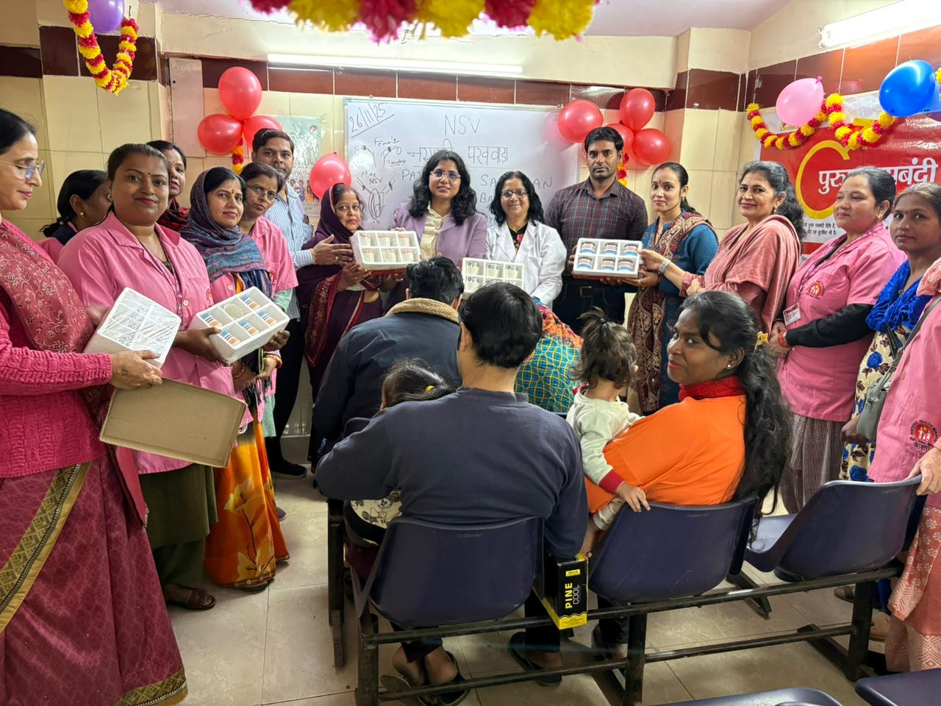
Pati-Patni Sammelan at DGD Pulbangash

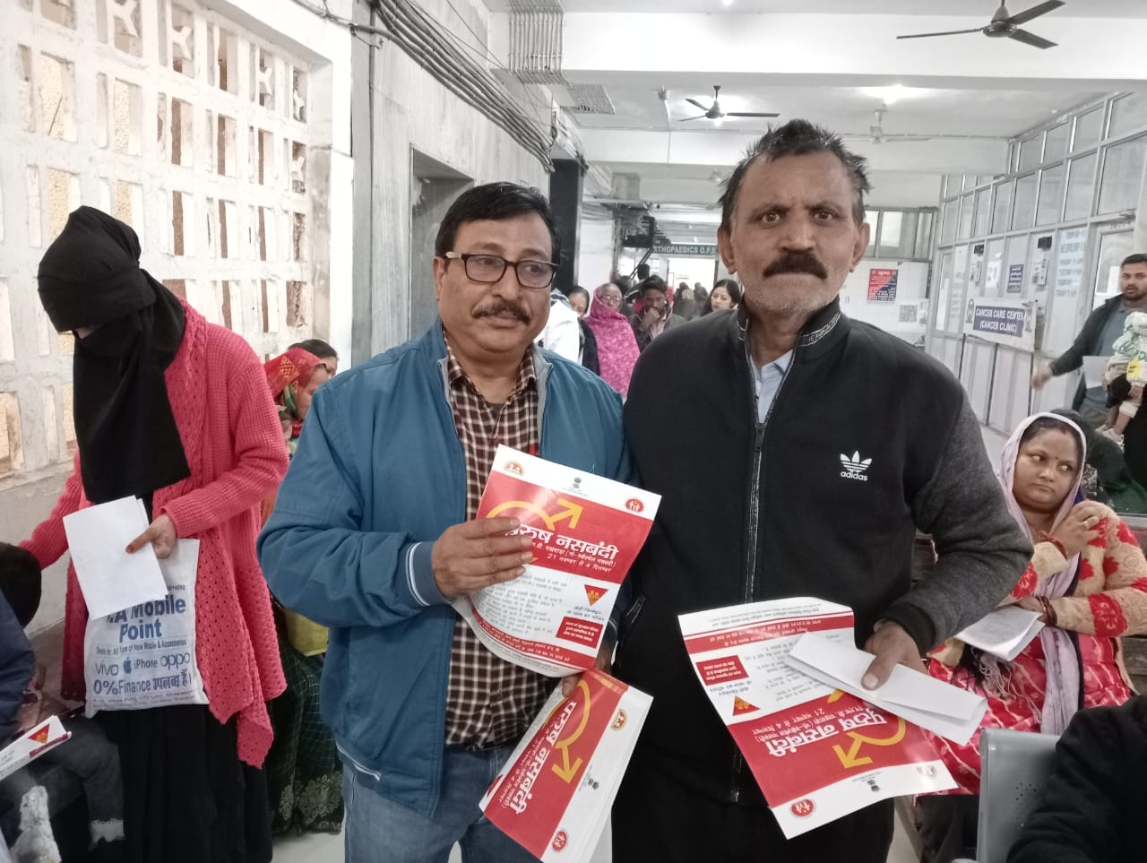

Health talk on nsv at Hindu Rao hospita dt 26.11.25
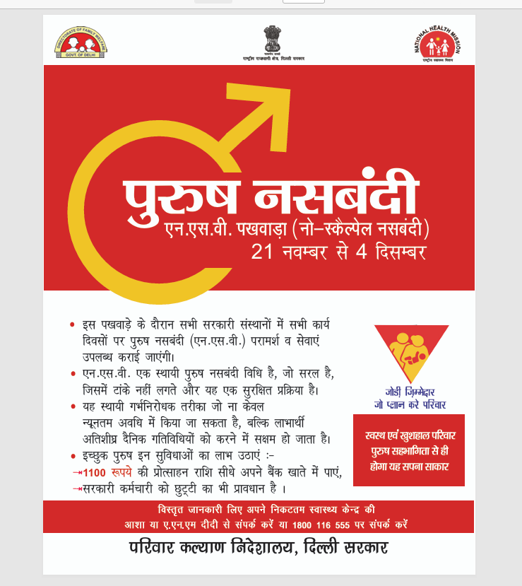
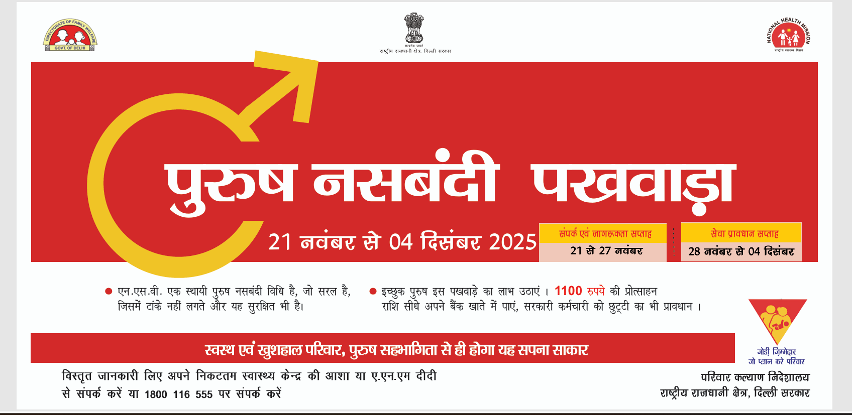

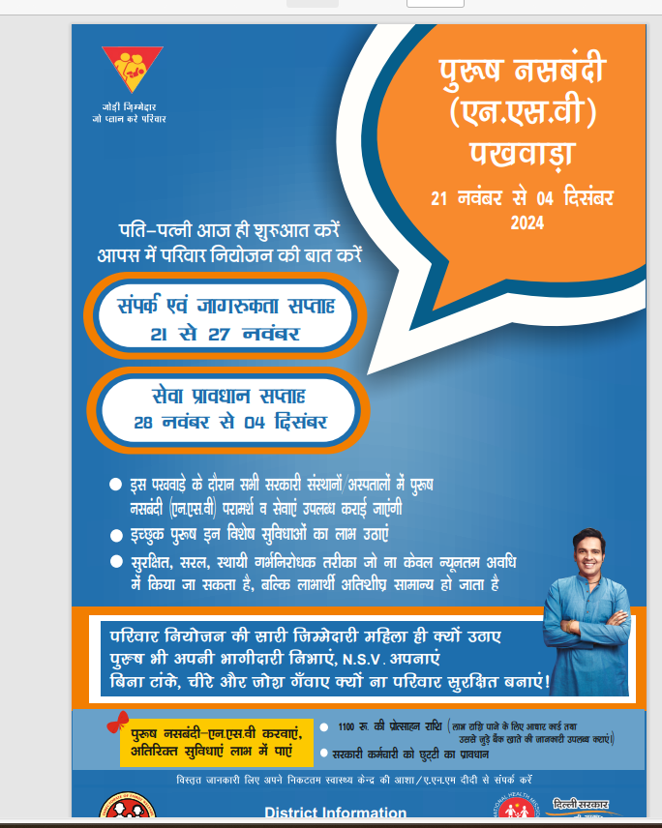
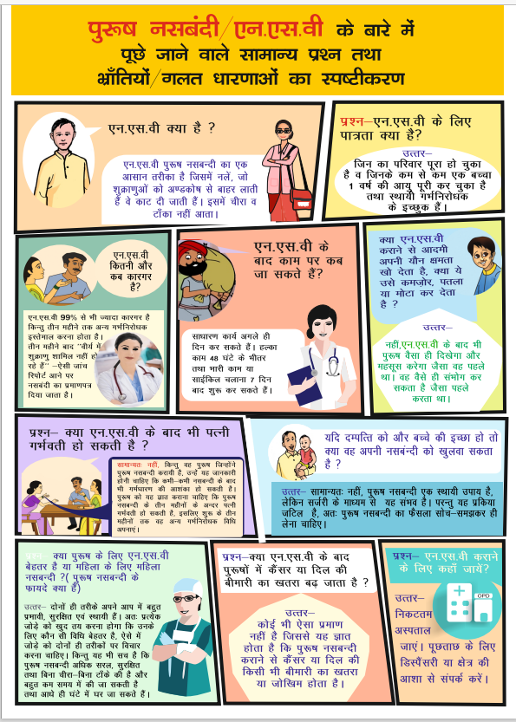

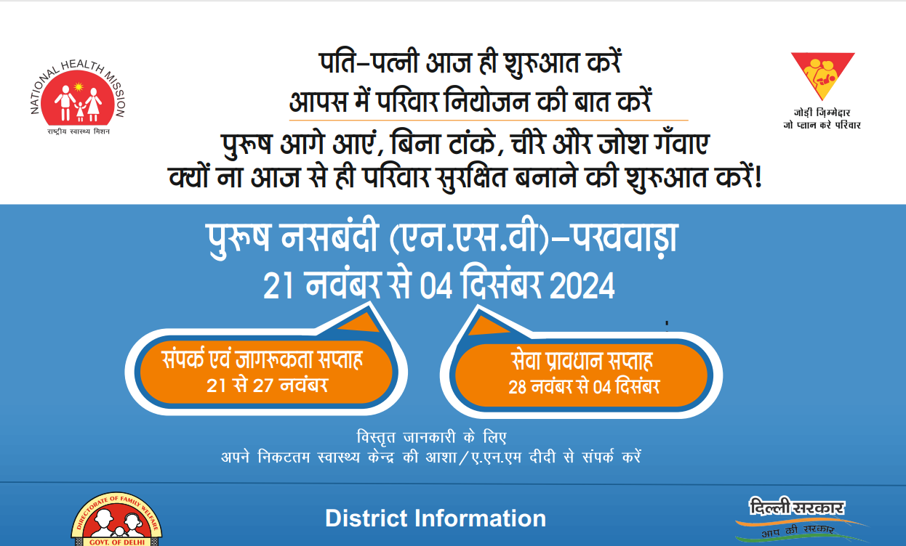

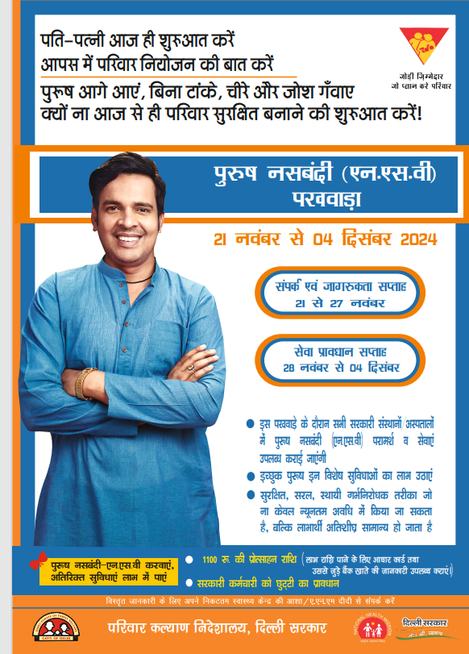

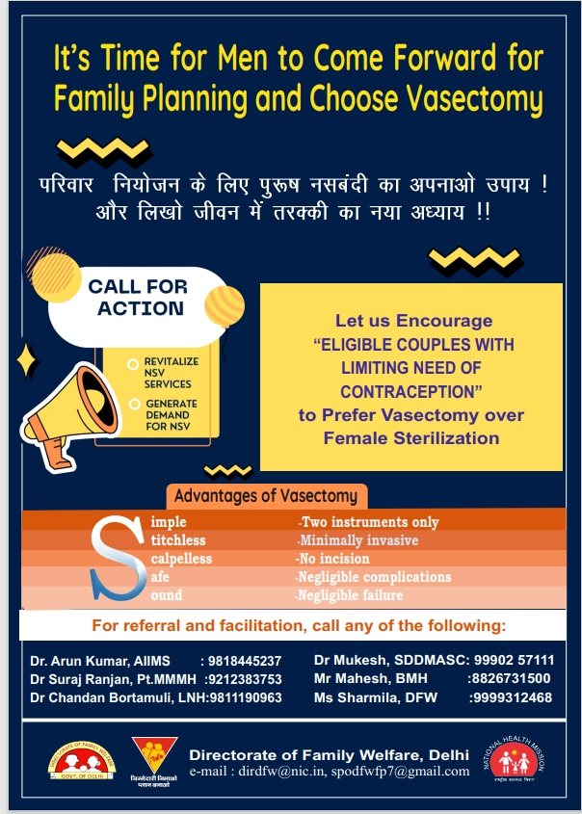
"Creative Feature Published in AOGD Bulletin for NSV Fortnight: Spreading Awareness, Inspiring Collaboration Request for NSV Fortnight 2024 Letter sent to various agencies across NCT of Delhi, CHS,ESI,MCD etc to
• Increase awareness about NSV among men and families within our communities.
• Provide education on the benefits and safety of NSV as a reliable family planning option.
• Encourage active participation from eligible men in availing NSV services. And for
- Conducting Awareness Campaigns
- Distributing IEC (Information, Education, and Communication) Materials
- Assisting with Logistical Support
- Leveraging Media Platforms
And thus, helping to spread the message of responsible family planning and empowering men to make informed decisions and create a significant impact during the NSV Fortnight and beyond.

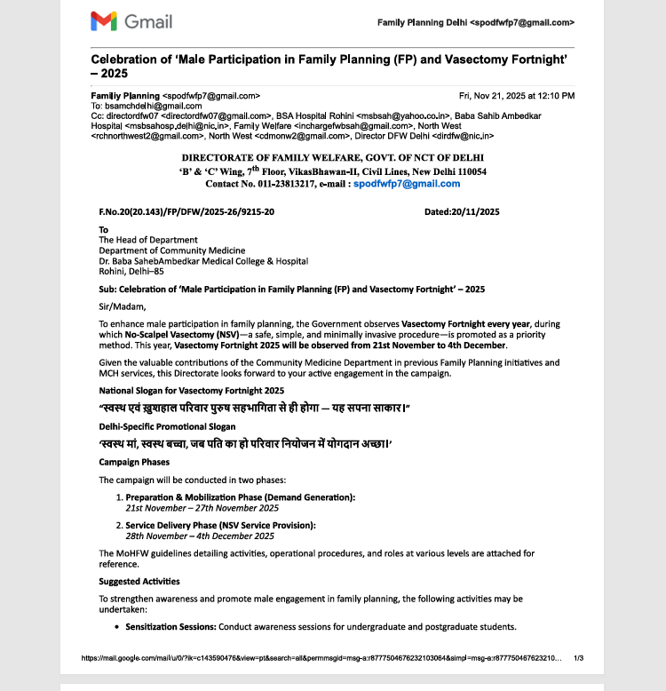
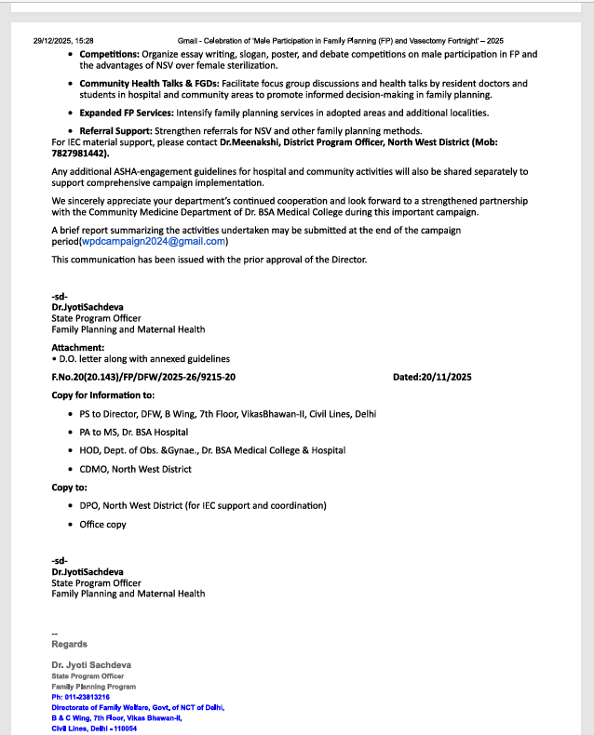

gh
District | Facility | Name of Surgeon | Total
Central | Lok Nayak Hospital | Dr. Chandan | 3
North West | B M Hospital | Dr. Krishnanandan | 1
SOUTH WEST | Dada Dev Hospital | DR. MUKESH KUMAR | 5
South West | Indira Gandhi hospital | DR. Deepika Aggarwal | 6
Central | Hindu Rao Hospital | Dr Satish Shorean | 2
Central | Burarai hospital | Dr Rohit | 1
New Delhi | RML Hospital | Dr Abu Masud/Dr Shardool | 1
North | MVH | Dr Parvinder | 1
Wesr | ASBG | Dr Anju | 1
 | Total |  | 26
Source-googlr sheet 67,FP Section, DFW

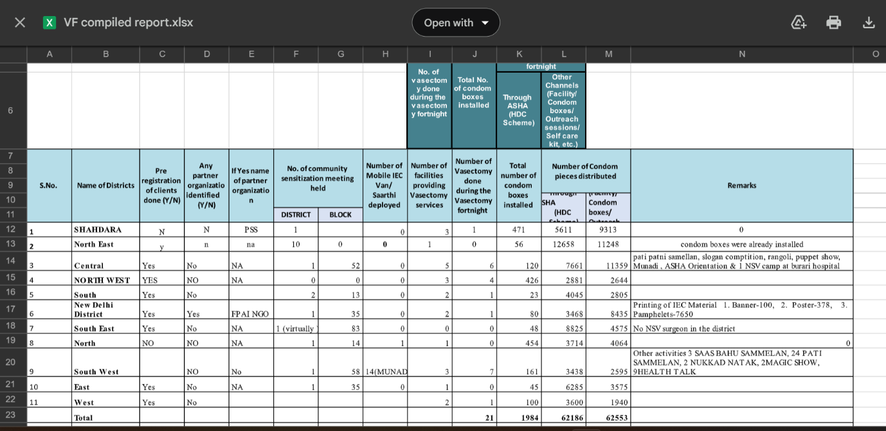

Source-google sheet, FP section, DFW

